ROF ABC-MZ

Automatic bias point control module
ROF-ABC-MZ series automatic bias control module is used for automatic bias control of lithium niobate M-Z modulator, which can make the modulator work stably at the lowest point, the highest point or the orthogonal point (linear region). The module is also integrated with 1/99 coupler, which can control the switching of the working point through the external serial port, and supports manual adjustment mode, which is suitable for a variety of different wavelength modulators and applications, and is very suitable for university laboratories to build desktop experiments.
Feature
Application

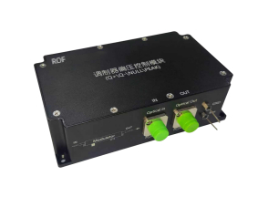
- Multiple bias operating modes are available (Quad+↔Quad-, Min ↔Max)
- Serial communication, programmed automatic fine tuning and locking bias points
- Internal component beamers support a variety of wavelengths
- Module package, adapter power supply
Application

- Optical fiber communication
- Microwave photon
- Pulsed light application
Parameters

Argument | Min | Typical | Max | Unit
Optical parameter
Input optical power 1* | 0 |  | 13 | dBm
Operating wavelength 2* | 780 |  | 1650 | nm
Optical fiber interface | FC/APC
Electrical parameter
Bias voltage | -10 |  | 10 | V
Switch extinction ratio 3* | 20 | 25 | 50 | dB
Mode-locked region | Positive or Negative
Lock mode | Quad+ (Quad-) or Min (Max)
Modulation depth (QUAD) |  | 1 | 2 | %
Modulation depth (Null) |  |  | 0.1 | %
Pilot frequency (QUAD) |  | 1K |  | Hz
Pilot frequency (NULL) |  | 2K |  | Hz
Conventional parameter
Dimensions (length × width × thickness) | 120×70×34 mm
Operating temperature | 0 - 70℃

Note:
1* refers to the power range input to the module when the modulator output is maximum. For the low point control of the modulator with a high extinction ratio, the input power should be appropriately increased; With special power input requirements, you can adjust the internal coupler and detector gain indicators, please consult sales when placing orders.
2* When placing an order, please specify the working wavelength, which needs to be optimized according to the working wavelength.
3* switching extinction ratio also depends on the switching extinction ratio level of the modulator itself.
Size drawing (mm)

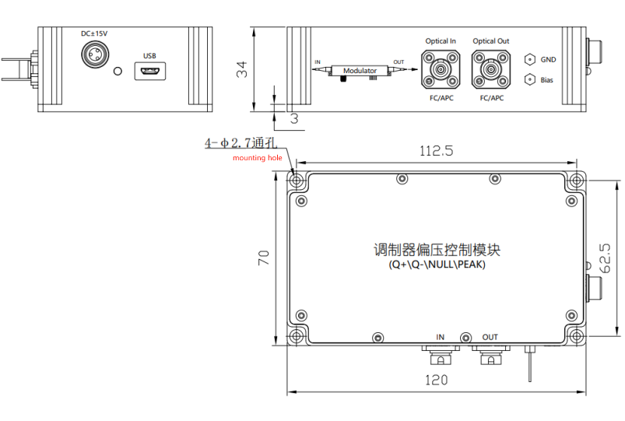
Ordering information

ROF | ABC | Modulator type | XX | XX | XX
 | Automatic bias point control module | MZ---M-Z modulator | Working wavelength:  15---1550nm  13---1310nm  10---1064nm  08---850nm  07---780nm | Fiber type:  S-- Single mode optical fiber  P - polarization-maintaining fiber | Optical fiber interface:  FA—FC/APC  FP---FC/UPC
*If you have any special requirements, please contact our sales staff

